**Project 1**

Title

**Yahtzee! V.3**

**Typing Tutor Game**

Course

CIS-5

Due Date

July 25, 2022

Author

Jessriel Menguito

**1 Introduction**

Yahtzee is a dice game made by Milton Bradley. The goal of the game is to score points by rolling five dice. The dice can be rolled up to three times in a turn. By selecting different combinations the players can set aside dice to score different combinations of points. The game has thirteen rounds and at the end of each round the player chooses which scoring category they want to use for that round. Once a category has been used, it cannot be used again. A Yahtzee is a five-of-a-kind that scores 50 points, the highest of all categories. The winner is the player who scores the most points.

**2 Game Play and Rules**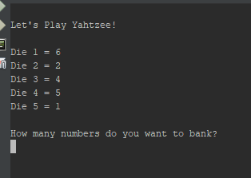

The game begins immediately with your initial dice roll. You then can decide which numbers you want to bank. The player can pick any number between zero and five. If a player chooses a number between one and five. The players will then be asked which dice they want to store in their bank. Once their choices have been made, they will be asked if they would like to reroll. If the player chose a zero at the beginning, they would also be brought to this choice. If yes, the program will loop, roll new numbers for the remaining dice and ask the same questions.

**3 Development Summary**

| Lines of Code | 354 |
| --- | --- |
| Comment Lines | 94 |
| Blank Lines (White Space) | 0 |
| Total Lines of Source File | 367 |

The project is in C++ which is encapsulated in multiple files. I used Apache NetBeans IDE 12.2

**3.1 Version 2 Comments on Development**

The project started as a completely different game. Initially it was a dice rolling game called Ship, Captain, Crew. It is a bar game that is entirely random with no user input. While it was a functioning game after revision 7, I decided to end the project. It was not accomplishing the goals dictated for this project. I was able to transplant the dice logic into this program and build from there.

**3.1.1 Rolling Dice More than Once**

I used a random number generator and limited the roll up to 6. Initially when I started, I had the dice roll occur before the for loop. Because the generator was initialized outside the for loop it did not reroll the die. I then tried to copy the die roll into the loop but each time the player decided to do a die roll, it would randomize the stored dice which were supposed to keep their value. To resolve this issue, I created another function so rolling occurred outside of the for loop but can be called in when needed. In order to protect the dice choices that were selected by the player, each randomizer bool is tied to each die respectively.

**3.1.2 Storing Dice**

The most difficult part for me was to figure out how to store the information between each dice roll. I used a function to store the information and a bool inside the function that determined if the die was stored or not. All dice bool’s started as true and as the user chose a die, it would set that die bool to false and would not be shown.

**3.1.3 Outputting the Score**

Yahtzee has a very unique scoring system. To score in Yahtzee, the player must bank their dice and at the end decide where to score. Given more time, I would create more functions to store the players score in each of the 13 rounds. For this project, I simplified the output to only what the player can possibly score. Currently, this program allows the player to run individual rounds but not an entire game.

**4 Specification**

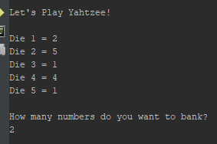

**4.1 Sample Inputs/Outputs**

This game uses single number and letter inputs. A player will be shown the first 6 dice rolls. They will be prompted on “How many numbers do you want to bank?”. The player will then need to input a number between zero and five. If a number is selected outside of this range, the player will be prompted again.

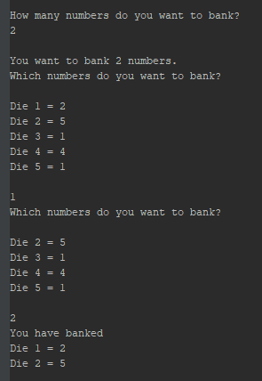

Once the player has selected the number of dice to bank. The player will need to select one die. Once selected, the prompt will repeat based on the number imputed by the player.

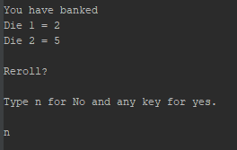

The player will then have an opportunity to reroll. The game will loop back to the top and repeat up to three times. If the player inputs n, the loop will end and the score will display.

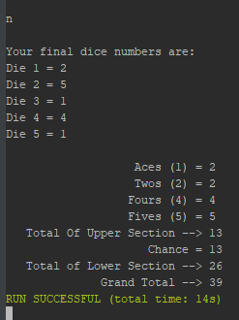

The game will display your final dice choices and show the points available to the player. If the point isn’t relevant, it isn’t shown. In the example to the right, a Die 3 was not in the final dice numbers so the “Threes (3)” are not shown.

**4.2 Dice Bank Logic**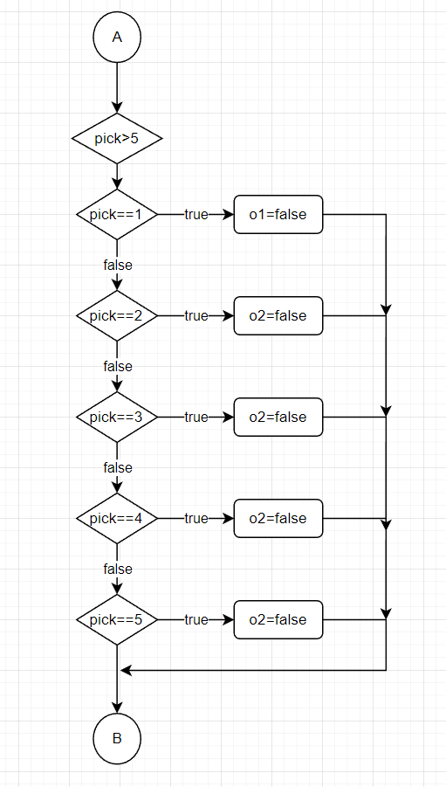

**5 Program Listing**

/*

* File: main.cpp

* Author: Jessriel Menguito

* Created on July 25, 2022, 6:23 PM

* Purpose: Project 1 - Yahtzee

*/

//System Libraries

#include <iostream>

#include <iostream>

#include <iomanip>

#include <cmath>

#include <cstdlib>

#include <fstream>

#include <string>

#include <ctime>

using namespace std;

//User Libraries

//Global Constants

//Mathematical/Physics/Conversions, Higher dimensioned arrays

//Function Prototypes

void dice(int,int,int,int,int,bool,bool,bool,bool,bool);

void dice2(int,int,int,int,int,bool,bool,bool,bool,bool);

void dice3(int,int,int,int,int,bool,bool,bool,bool,bool);

//Execution Begins Here

int main(int argc, char** argv) {

ofstream outputFile;

outputFile.open("YahtzeeScore.txt");

//Initialize the RAndom Number Seed

//Declare Variables

int d1,d2,d3,d4,d5,round,loop1=0,fin;

int choice1,pick,count,t1=0,t2=0,t3=0,t4=0,t5=0,t6=0,t7=0,t8=0,t9=0,t10=0,t11=0;

int die,count1,count2=0,choice=5;

string title;

bool o1=true,o2=true,o3=true,o4=true,o5=true;

char yn,y,n;

int const game=1,

rules=2;

//Initialize Variables

srand(time(0));

die=6; //How many dice and reroll

d1=rand()%die+1;

d2=rand()%die+1;

d3=rand()%die+1;

d4=rand()%die+1;

d5=rand()%die+1;

title="Let's Play Yahtzee!"; //Title can be changed

//Map inputs to outputs -> The Process

cout<<endl<<title<<endl<<endl;

do{ //Main Loop

round=3;

dice3(d1,d2,d3,d4,d5,o1,o2,o3,o4,o5);

dice(d1,d2,d3,d4,d5,o1,o2,o3,o4,o5);

cout<<endl;

cout<<"How many numbers do you want to bank?"<<endl;

do{ //Check to see if user inputs a number 5 or less

cin>>choice1; //User input how many numbers

if(choice1>5){

cout<<"Please choose a number between 0 and 5"<<endl;

}

}while (choice1<0||choice1>5); //while loop to check what dice to remove

cout<<endl<<"You want to bank "<<choice1<<" numbers."<<endl;

if (choice1>0){ //User input

for (loop1=0;loop1<choice1;loop1++){ //Loop the dice to remove

cout<<"Which numbers do you want to bank?"<<endl<<endl;

dice(d1,d2,d3,d4,d5,o1,o2,o3,o4,o5);//Call dice bank

cout<<endl;

do{

cin>>pick; //User input which die to pick

if(choice1>5){

cout<<"Please choose a number between 0 and 5"<<endl;

}

}while(pick>5); //Verify if input is less than 5

if (pick==1){//Die 1

o1=false;

}

if (pick==2){//Die 2

o2=false;

}

if (pick==3){//Die 3

o3=false;

}

if (pick==4){//Die 4

o4=false;

}

if (pick==5){//Die 5

o5=false;

}

}

}

dice2(d1,d2,d3,d4,d5,o1,o2,o3,o4,o5); //Call dice bank 2 to show what was set aside

cout<<endl<<"Reroll?"<<endl<<endl;

cout<<"Type n for No and any key for yes."<<endl<<endl; //Ask the user if they want a reroll

cin>>yn;

if (yn=='n'||yn=='N'){

count2=round;

}

else

count2++;

}while (count2<round);

cout<<endl<<"Your final dice numbers are:"<<endl;

cout << "Die 1 = "<<d1<<endl;

cout << "Die 2 = "<<d2<<endl;

cout << "Die 3 = "<<d3<<endl;

cout << "Die 4 = "<<d4<<endl;

cout << "Die 5 = "<<d5<<endl<<endl;

//Scoring Below

cout<<fixed<<setw(30)<<right;

if (d1==1||d2==1||d3==1||d4==1||d5==1){//Check to see if number is equal to one

if (d1==1){//check die 1

t1+=1;

}

if (d2==1){//check die 2

t1+=1;

}

if (d3==1){//check die 3

t1+=1;

}

if (d4==1){//check die 4

t1+=1;

}

if (d5==1){//check die 5

t1+=1;

}

cout << "Aces (1) = "<<t1<<endl; //output if there are any ones

}

if (d1==2||d2==2||d3==2||d4==2||d5==2){ //check to see if number is equal to two

if (d1==2){//check die 1

t2+=2;

}

if (d2==2){//check die 2

t2+=2;

}

if (d3==2){//check die 3

t2+=2;

}

if (d4==2){//check die 4

t2+=2;

}

if (d5==2){//check die 5

t2+=2;

}

cout <<fixed<<setw(30)<<right<< "Twos (2) = "<<t2<<endl;

}

if (d1==3||d2==3||d3==3||d4==3||d5==3){ //check to see if the number is equal to three

if (d1==3){//check die 1

t3+=3;

}

if (d2==3){//check die 2

t3+=3;

}

if (d3==3){//check die 3

t3+=3;

}

if (d4==3){//check die 4

t3+=3;

}

if (d5==3){//check die 5

t3+=3;

}

cout <<fixed<<setw(30)<<right<< "Threes (2) = "<<t3<<endl;

}

if (d1==4||d2==4||d3==4||d4==4||d5==4){//check to see if the number is equal to four

if (d1==4){//check die 1

t4+=4;

}

if (d2==4){//check die 2

t4+=4;

}

if (d3==4){//check die 3

t4+=4;

}

if (d4==4){//check die 4

t4+=4;

}

if (d5==4){//check die 5

t4+=4;

}

cout <<fixed<<setw(30)<<right<< "Fours (4) = "<<t4<<endl;

}

if (d1==5||d2==5||d3==5||d4==5||d5==5){//check to see if the number is equal to five

if (d1==5){//check die 1

t5+=5;

}

if (d2==5){//check die 2

t5+=5;

}

if (d3==5){//check die 3

t5+=5;

}

if (d4==5){//check die 4

t5+=5;

}

if (d5==5){//check die 5

t5+=5;

}

cout <<fixed<<setw(30)<<right<< "Fives (5) = "<<t5<<endl;

}

if (d1==6||d2==6||d3==6||d4==6||d5==6){//check to see if the number is equal to six

if (d1==6){//check die 1

t6+=6;

}

if (d2==6){//check die 2

t6+=6;

}

if (d3==6){//check die 3

t6+=6;

}

if (d4==6){//check die 4

t6+=6;

}

if (d5==6){//check die 5

t6+=6;

}

cout <<fixed<<setw(30)<<right<< "Six (6) = "<<t6<<endl;

}

t7=t1+t2+t3+t4+t5;

if (t7>63){//see if the user has scored over 63

t7+=63;

cout <<fixed<<setw(30)<<right<< "Bonus 35 points if total score is 63 or over = "<<endl;

}

cout <<fixed<<setw(30)<<right<< "Total Of Upper Section --> "<<t7<<endl;

if (d1==d2==d3||d1==d2==d4||d1==d2==d5||d2==d3==d4||d2==d3==d5||d1==d4==d5||d2==d4==d5){//check if there are three of the same

if (d1==d2==d3){//check triplet 1

t8=d1+d2+d3;

}

else if (d1==d2==d4){//check triplet 2

t8=d1+d2+d4;

}

else if (d1==d2==d5){//check triplet 3

t8=d1+d2+d5;

}

else if (d2==d3==d4){//check triplet 4

t8=d2+d3+d4;

}

else if (d2==d3==d5){//check triplet 5

t8=d2+d3+d5;

}

else if (d1==d4==d5){//check triplet 6

t8=d1+d4+d5;

}

else if (d2==d4==d5){//check triplet 7

t8=d2+d4+d5;

}

else{

cout<<"error";

}

cout<<fixed<<setw(30)<<right<<"3 of a kind (Add total of all dice) = "<<t8<<endl;

}

if (d1==d2==d3==d4||d1==d2==d3==d5||d1==d2==d4==d5||d1==d3==d4==d5||d2==d3==d4==d5){

if (d1==d2==d3==d4){//check quad 1

t9=d1+d2+d3+d4;

}

if (d1==d2==d3==d5){//check quad 2

t9=d1+d2+d3+d5;

}

if (d1==d2==d4==d5){//check quad 3

t9=d1+d2+d4+d5;

}

if (d1==d3==d4==d5){//check quad 4

t9=d1+d3+d4+d5;

}

if (d2==d3==d4==d5){//check quad 5

t9=d2+d3+d4+d5;

}

cout<<fixed<<setw(30)<<right<<"4 of a kind (Add total of all dice) = "<<t9<<endl;

}

if (d1==d2==d3||d1==d2==d4||d1==d2==d5||d2==d3==d4||d2==d3==d5||d1==d4==d5||d2==d4==d5){//Check for a triplet first

if (d1==d2==d3){

if (d4==d5){//Check if there is a pair with the remaining

t10=d1+d2+d3+d4+d5;

}

}

if (d1==d2==d4){

if (d3==d5){//Check if there is a pair with the remaining

t10=d1+d2+d3+d4+d5;

}

}

if (d1==d2==d5){

if (d4==d3){//Check if there is a pair with the remaining

t10=d1+d2+d3+d4+d5;

}

}

if (d2==d3==d4){

if (d1==d5){//Check if there is a pair with the remaining

t10=d1+d2+d3+d4+d5;

}

}

if (d2==d3==d5){

if (d4==d1){//Check if there is a pair with the remaining

t10=d1+d2+d3+d4+d5;

}

}

if (d1==d4==d5){

if (d2==d3){//Check if there is a pair with the remaining

t10=d1+d2+d3+d4+d5;

}

}

if (d2==d4==d5){

if (d1==d3){//Check if there is a pair with the remaining

t10=d1+d2+d3+d4+d5;

}

}

cout<<fixed<<setw(30)<<right<<"Full House (Score 25) = "<<t10<<endl;

}

if (t10==10||t10==14){//Sum of 1-4=10, Sum of 2-5=14

t10+=25;

cout <<fixed<<setw(30)<<right<< "SM Straight (Sequence of 5)(Score 30) = "<<t10<<endl;

}

if (t10==15){//Sum of 1-5=15

t10+=40;

cout <<fixed<<setw(30)<<right<< "LG Straight (Sequence of 5)(Score 40) = "<<t10<<endl;

}

if (d1==d2==d3==d4==d5){//If all of the numbers are the same

t10+=50;

cout <<fixed<<setw(30)<<right<< "Yahtzee!= 50 Points"<<d3<<endl;

}

cout <<fixed<<setw(30)<<right<< "Chance = "<<d1+d2+d3+d4+d5<<endl;

t11=t10+t9+t8+t7+t6+t5+t4+t3+t2+t1;//Add all totals together

cout<<fixed<<setw(30)<<right<<"Total of Lower Section --> "<<t11;

fin=t7+t11;

cout<<fixed<<setw(30)<<right<<endl<<"Grand Total --> "<<fin;

outputFile<<fin;

//Close the file

outputFile.close();

//Display Results

//Exit stage right

return 0;

}

void dice(int d1,int d2,int d3,int d4,int d5,bool o1,bool o2,bool o3,bool o4,bool o5){

if (o1==true)

cout << "Die 1 = "<<d1<<endl;

if (o2==true)

cout << "Die 2 = "<<d2<<endl;

if (o3==true)

cout << "Die 3 = "<<d3<<endl;

if (o4==true)

cout << "Die 4 = "<<d4<<endl;

if (o5==true)

cout << "Die 5 = "<<d5<<endl;

}

void dice2(int d1,int d2,int d3,int d4,int d5,bool o1,bool o2,bool o3,bool o4,bool o5){

cout<<"You have banked"<<endl;

if (o1==false)

cout << "Die 1 = "<<d1<<endl;

if (o2==false)

cout << "Die 2 = "<<d2<<endl;

if (o3==false)

cout << "Die 3 = "<<d3<<endl;

if (o4==false)

cout << "Die 4 = "<<d4<<endl;

if (o5==false)

cout << "Die 5 = "<<d5<<endl;

}

void dice3(int d1,int d2,int d3,int d4,int d5,bool o1,bool o2,bool o3,bool o4,bool o5){

int die=6;

if (o1==true)

d1=rand()%die+1;

if (o2==true)

d2=rand()%die+1;

if (o3==true)

d3=rand()%die+1;

if (o4==true)

d4=rand()%die+1;

if (o5==true)

d5=rand()%die+1;

}